Push the image to the IBM Cloud Registry

1. From your account dashboard, go to **IBM Cloud Kubernetes Service**.
2. From the left navigation menu, select **Private Repositories**.

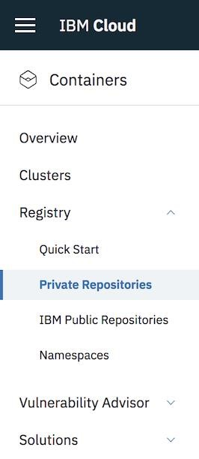

1. Install the Container Registry plug-in.
2. IBM cloud plugin install container-registry -r "IBM Cloud"

|  |
| --- |
|  |

1. Log in to your IBM Cloud account.

|  |  |
| --- | --- |
| 6. IBM cloud login -a <cloud_foundary_end_point_for_the_region> | |
|  |  |

1. Name and create your namespace. Use this namespace for the rest of the Quick Start.

1. ibmcloud cr namespace-add <namespace>

|  |
| --- |
|  |

1. Log your local Docker daemon into the IBM Cloud Container Registry.
2. ibmcloud cr login

|  |
| --- |
|  |

1. Choose a repository and tag by which you can identify the image.
2. docker tag <image_name> <region_url>/<namespace>/<image_name>:<tag>

|  |
| --- |
|  |

1. Push the image.
2. docker push <region_url>/<namespace>/<image_name>:<tag>

|  |
| --- |
|  |



1. Verify that your image is in your private registry.
2. ibmcloud cr image-list

